PRODUCT DESCRIPTIONS

https://bs413.infusionsoft.app/app/storeFront/showStoreFront

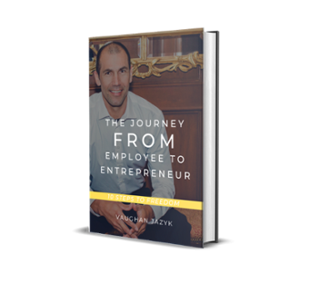

Employee to Entrepreneur (eBook)
$20.00
An eBook describing Vaughan Jazyk's journey from employee to entrepreneur. Vaughan describes the steps required to make this transition.
Quantity
Add to Cart

Product Description
Vaughan Jazyk describes his journey from employee to entrepreneur and provides the steps required to make this transition.

https://bs413.infusionsoft.app/app/storeFront/showProductDetail?productId=69

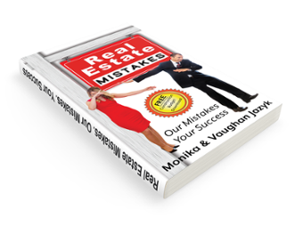

Real Estate Mistakes: Our Mistakes, Your Success (eBook) 2nd edition
$20.00
A must read for anyone who craves a realistic approach to real estate investing. In this eBook, the Jazyk family teaches us how we can avoid costly mistakes that can break the bank, while sharing the mindset of successful real estate investors.

https://bs413.infusionsoft.app/app/storeFront/showProductDetail?productId=133

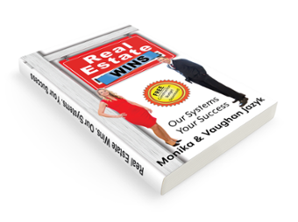

Real Estate Wins: Our Systems. Your Success.
$20.00
A must read eBook for anyone who craves a realistic approach to real estate investing. In the follow up to Real Estate Mistakes: Our Mistakes, Your Success, the Jazyk family teaches us their systems used to generate wealth in real estate.

https://bs413.infusionsoft.app/app/storeFront/showProductDetail?productId=136

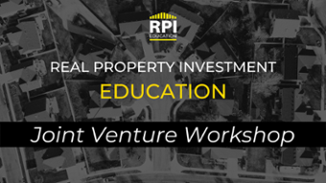

Joint Venture Workshop
$997.00
On-line Course (Workbook and Appendix and Recording
Quantity
Add to Cart

Product Description
Want to Invest in Real Estate But You Are....
- Out of Money?
- Out leveraged?
- Both?
This course Will Teach You A Proven System for Acquiring Funding Partners Helping YOU Grow Your Real Estate Portfolio.
Joint Venture 1 Day Workshop!
Proven system for acquiring funding partners
Match the right funding partner to the right property

Learn how:
- Active hands-on investor can find & oversee the property
- Passive hands-off investor can fund the property
- Active & passive joint venture partners share the wealth

Outline:
1. Know your numbers
2. JV system & procedures
3. Identify potential JV partners
4. Develop a JV partner
5. Influence techniques
6. Write targeted proposals
7. JV paperwork & contract
8. Overcome JV obstacles
9. Exiting your JV
https://bs413.infusionsoft.app/app/storeFront/showProductDetail?productId=28

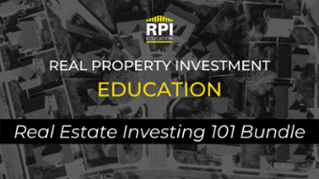

1. Real Estate Investing 101 - Bundle
$1,500.00
Course bundle contains 6 of our most popular introductory courses.
Quantity
Add to Cart

Product Description
This bundle ensures that you will be investing in real estate with confidence. This popular bundle contains the following courses:

- How to be a "Picky Investor" - Building Your Real Estate model.
- How to calculate the numbers.
- How to use a Cashflow Analyzer.
- How to use a Comparable Property Analyzer.
- How to Find Deals.
- How to build Your dream team.

Courses will be delivered as recorded video with workbooks and analyzers. Everything you need to learn at your own pace.

https://bs413.infusionsoft.app/app/storeFront/showProductDetail?productId=67



1a. How to Build Your Real Estate model
$299.00
7 steps teaching you how to build your real estate model
Quantity
Add to Cart

Product Description
By the end of this module you will be crystal clear on what type of investment strategy you will focus on , where to invest, clarity on financing and capital requirements, expected returns and how to create turn key systems that work for you.
You will discover how to Build your real estate model and get winning results every time!
You will receive:
- Video Tutorial: Hosted by Monika Jazyk, Real Estate Investor and founder of Real Property Investments
- Learning Companion: Workbook, highlighting each of the 7 steps, with important information about various investment strategies and activities for you to complete to reach your goals faster!
https://bs413.infusionsoft.app/app/storeFront/showProductDetail?productId=56

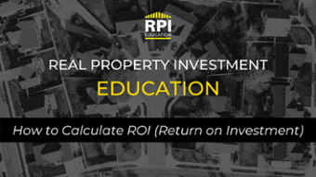

1b. How to Calculate the Numbers
$299.00
This module delves deep into teaching you the importance of knowing your numbers and how to calculate your ROI.
Quantity
Add to Cart

Product Description
You will discover:
- What is ROI
- Why do you need to know ROI in Real Estate Investing?
- What are the different components of ROI and what does each one mean?
- How do you Calculate ROI?
- How can you control your ROI?
- What aspects of ROI should you focus on in accordance to specific strategies?
- How do you explain ROI to JV partners and lenders?
We will use a live example and demonstrate how to calculate ROI.
By the end of this module, you will have a full understanding of what ROI is, how it works and how to calculate ROI.
You will be able to analyze various investments models according to each of the components that make up ROI , allowing you not only being able to understand a good investment over a bad investment, but having the ability to create great deals!
You will receive:
- Video Tutorial: Hosted by Monika Jazyk, Real Estate Investor and founder of Real Property Investments.
- Learning Companion: Workbook, highlighting each component of ROI steps, the rules of calculating ROI and your ROI glossary.

https://bs413.infusionsoft.app/app/storeFront/showProductDetail?productId=58

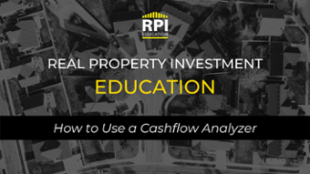

1c. How to Use a Cashflow Analyzer
$299.00
Cashflow is often misunderstood. This module will teach you everything you need to know about cashflow.
Quantity
Add to Cart

Product Description
You will discover:

- What is cashflow?
- How do you Calculate cashflow?
- How can you control your cashflow?
- What are realistic expectations for cashflow accordance to specific strategies?
- How to use a cashflow analyzer to find out if your property is cashflow positive or negative in 30 seconds flat!

We will use a live example and demonstrate how to calculate cashflow giving you a full demo of how to use the cashflow analyzer.

By the end of this module, you will have a full understanding of what cashflow is, how it works and how to calculate cashflow in 30 seconds flat!

You will receive:

- Video Tutorial: Hosted by Monika Jazyk, Real Estate Investor and founder of Real Property Investments
- Tool: Cashflow analyzer

https://bs413.infusionsoft.app/app/storeFront/showProductDetail?productId=60

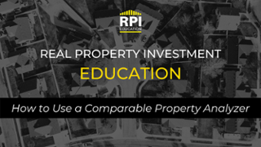

1d. How to Use a Comparable Property Analyzer
$299.00
The Comparable Property Analyzer will allow you to - nail the numbers when purchasing buy rent hold and flip properties.
Quantity
Add to Cart

Product Description
By the end of this module, you will have a full understanding of how to use this handy tool and will be ready to put in winning offers!

This module gives you a series of step-by-step guidelines to follow including key calculations and expert tips so nothing is left to chance.
We will use a live example and demonstrate how to use the comparable property analyzer so you will know how to calculate the price of properties per square foot.

You will receive:

- Video Tutorial: Hosted by Monika Jazyk, Real Estate Investor and founder of Real Property Investments
- Tool: Comparable Property Analyzer

https://bs413.infusionsoft.app/app/storeFront/showProductDetail?productId=62



1e. How to Find Deals
$299.00
This module explains a 7 step system showing you how to find deals, even in hot markets where no deals seem to be available.
Quantity
Add to Cart

Product Description
This module explains a 7 step system showing you how to find deals, even in hot markets where no deals seem to be available.

By the end of this module you will be able to locate deals in any market by using this proven methodology without any dated techniques such as yellow letter campaigns, tacky bandit signs and “We Buy Houses” ads.

Get ready to implement a more sophisticated methodology that will have deals come to you.
You will receive:

- Video Tutorial: Hosted by Monika Jazyk, Real Estate Investor and founder of Real Property Investments
- Learning Companion: Workbook, highlighting each of the 7 steps, helping you locate deals in any market

https://bs413.infusionsoft.app/app/storeFront/showProductDetail?productId=64



1f. How to Build Your Dream Team
$299.00
Having a rock solid team at your side can mean the difference between success and failure. Finding the right professionals early in your investing journey will save you both money and time and set you up for more profits.
Quantity
Add to Cart

Product Description
Finding the right professionals early in your investing journey will save you both money and time and set you up for more profits.
You will discover:

- How to build your real estate dream team
- Who needs to be on your team
- How to find them and WHAT to expect from them.
- How to get the best experts in your inner circle working with you
- How to communicate strategically to get the best from your team

You will receive:

- Video Tutorial: Hosted by Monika Jazyk, Real Estate Investor and founder of Real Property Investments
- Learning Companion: Workbook, highlighting essentials team members and a script of Interview questions for each team member.
https://bs413.infusionsoft.app/app/storeFront/showProductDetail?productId=66

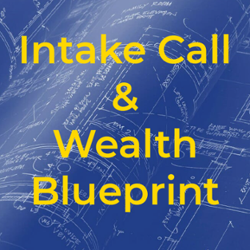

Intake Call & Wealth Blueprint
$1,000.00
Your intake call is the foundation for your success. Financial goals are objectives or milestones that you want your money to cover at a specific time. We explore where you want to be in 5 years and provide steps to develop a plan.
Quantity
Add to Cart

Product Description
Your intake call and wealth blueprint determines what your financial goals are and provides a roadmap to success. This isn't a get rich quick plan. We determine what your comfort level is in being either an Active Investor or a Passive Investor. Perhaps it's both.
From there we create a blueprint to success with you.
This is the foundation required to help guide you on your investment journey.

https://bs413.infusionsoft.app/app/storeFront/showProductDetail?productId=74



1 on 1 coaching with Monika Jazyk
$0.00
1 on 1 coaching with Monika Jazyk. Please select either 5 or 10 hours.
Hours of Coaching | Please select Hours of Coaching5 hours coaching + $2,500.0010 hours + $5,000.00
Quantity
Add to Cart

Product Description
This package provides you with 1 on 1 coaching with Monika Jazyk over a period of 12 months. Time is blocked off in 30 minute increments. Review your portfolio or discuss investment opportunities. (Select either a 5 or 10 hour package)
Monika Jazyk is a wife and proud mother of four wonderful, yet expensive, children. After the completion of her master’s in teaching and birth of her eldest son, Monika chose to stay home with her growing family, sacrificing income of a full-time wage. To create monthly income to be able to fund immediate and future expenses for her children, Monika and her husband Vaughan chose Real Estate as an investment vehicle to build passive income and long-term wealth.
Monika is also co-owner of Real Property Investments, a Real Estate Investment Corporation that helps Real People build Real wealth through Real Estate! Monika is passionate about helping other people create wealth through Real Estate and alternative investments so they can reach their financial and personal goals.
https://bs413.infusionsoft.app/app/storeFront/showProductDetail?productId=102

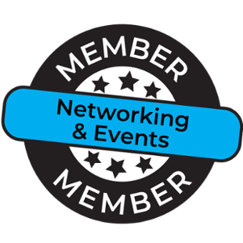

Networking & Events
- $50.00 Every month
- $300.00 Every year
Access to recorded videos as well as live events.
Quantity
Add to Cart

Product Description
JOIN THIS MEMBERSHIP AND YOU WILL HAVE ACCESS TO:

EDUCATION, EVENTS & EXPERTS:
- Access to our library of Real Estate training webinars and videos on our Members Only Site
- Access to monthly networking event recordings featuring industry experts.
ADDED BONUS!
- FREE download of our book "Real Estate Mistakes. Our Mistakes. Your Success"
Please note: Cancellation of the month to month option of your RPI Education Membership requires a minimum of 30-days’ written notice. Notice can be submitted to info@rpinvestments.ca.
By purchasing this plan, you agree that you are purchasing a subscription that is charged on a recurring basis. Your plan will automatically renew until you cancel your plan (either yearly or monthly).

https://bs413.infusionsoft.app/app/storeFront/showProductDetail?productId=8

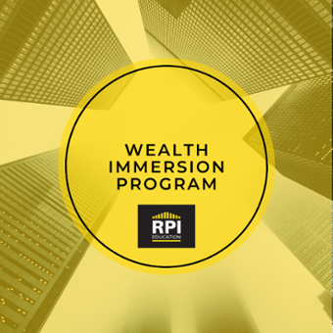

Wealth Immersion Program
- One Time of $1,997.00
- $1,997.00 Every year
- $199.00 Every month for 12 months
This immersive self-paced course will guide you through 7 modules that the top 2% focus on so you can start growing and protecting your wealth just like them.
Quantity
Add to Cart

Product Description
This immersive course will walk you through 7 modules that the top 2% use to grow and protect their wealth. This is a self paced course designed to walk you through each module with recorded webinars, activities and downloads. This course resides on the Teachable Platform.
You will be sent an email follow up with a link to finalize your product purchase on their platform. Click here to create a free account with them.
Your purchase also includes a year of membership including Group Coaching every other Thursday and access to events throughout the year.
By purchasing this plan, you agree that you are purchasing a subscription that is charged on a recurring basis. Your plan will automatically renew until you cancel your plan (either yearly or monthly). 30-days notice is required to cancel your subscription.

https://bs413.infusionsoft.app/app/storeFront/showProductDetail?productId=121

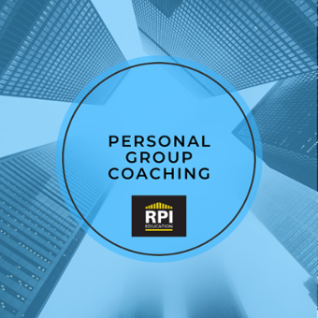

Group Coaching - Personal - 3 MONTHS
$3,000.00
Quantity
Add to Cart

Product Description
*** This Membership package requires you to participate in an Intake Call (included). Please ensure you have completed and scheduled your call after placing your order.
__________________________________________________________________________

JOIN THIS MEMBERSHIP AND YOU WILL HAVE ACCESS TO:
EDUCATION, EVENTS & EXPERTS:

- 3 x RPI Education Personal Group Coaching accountability calls (on-line monthly)
- Access to a private FB page to network with other members and post questions.
- Access to our library of Real Estate training webinars and videos on our Members Only Site
- Access to 6 x Deals and Group Coaching meetings (2/month)
- Complimentary entry to our monthly networking events featuring industry experts (plus access to recordings)
- Priority Access to additional training, dinners, seminars, and Investor Field Training
- Access to our Real Estate Team (Lawyers, Accountants, Mortgage Brokers, Real Estate Agents, Home Inspector, Property Managers, Insurance Reps and Contractors)
TOOLS:

- Cash-flow analyzer
- Comparable Properties Worksheet
- Pre-Purchase Inspection Checklist
- Legal Agreements for Leases
- Legal Agreements for Joint Ventures
- Your personalized 5-year wealth building plan (template)
DEALS:

- Exclusive access to off market investment opportunities.
COACHING

- Access to 6 Deals and Group Coaching (online) Webinars
- 3 Monthly Accountability Calls (online) where we focus on you.
- Creation of your personalized action plan to wealth
- Ongoing support to keep you on track.
ADDED BONUS!

- FREE download of our book "Real Estate Mistakes. Our Mistakes. Your Success"
Please note: Cancellation of the month to month option of your RPI Education Membership requires a minimum of 30-days’ written notice. Notice can be submitted to info@rpinvestments.ca.
By purchasing this plan, you agree that you are purchasing a subscription that is charged on a recurring basis. Your plan will automatically renew until you cancel your plan (either yearly or monthly).

https://bs413.infusionsoft.app/app/storeFront/showProductDetail?productId=125



Group Coaching - Personal - 6 MONTHS
$5,000.00
Quantity
Add to Cart

Product Description
*** This Membership package requires you to participate in an Intake Call (included). Please ensure you have completed and scheduled your call after placing your order.
__________________________________________________________________________

JOIN THIS MEMBERSHIP AND YOU WILL HAVE ACCESS TO:
EDUCATION, EVENTS & EXPERTS:
- 6 x RPI Education Personal Group Coaching accountability calls (on-line monthly excludes July/August)
- Access to a private FB page to network with other members and post questions.
- Access to our library of Real Estate training webinars and videos on our Members Only Site
- Access to 12 x Deals and Group Coaching meetings (2/monthly excludes July/August))
- Complimentary entry to our monthly networking events featuring industry experts (plus access to recordings)
- Priority Access to additional training, dinners, seminars, and Investor Field Training
- Access to our Real Estate Team (Lawyers, Accountants, Mortgage Brokers, Real Estate Agents, Home Inspector, Property Managers, Insurance Reps and Contractors)
TOOLS:
- Cash-flow analyzer
- Comparable Properties Worksheet
- Pre-Purchase Inspection Checklist
- Legal Agreements for Leases
- Legal Agreements for Joint Ventures
- Your personalized 5-year wealth building plan (template)
DEALS:
- Exclusive access to off market investment opportunities.
COACHING
- Access to 12 Deals and Group Coaching (on-line monthly excludes July/August) Webinars
- 6 Monthly Accountability Calls (online excludes July/August) where we focus on you.
- Creation of your personalized action plan to wealth
- Ongoing support to keep you on track.
ADDED BONUS!
- FREE download of our book "Real Estate Mistakes. Our Mistakes. Your Success"
- 6 months FREE Access to our Wealth Immersion Program (Value:$1,997)
Please note: Cancellation of the month to month option of your RPI Education Membership requires a minimum of 30-days’ written notice. Notice can be submitted to info@rpinvestments.ca.
By purchasing this plan, you agree that you are purchasing a subscription that is charged on a recurring basis. Your plan will automatically renew until you cancel your plan (either yearly or monthly).

https://bs413.infusionsoft.app/app/storeFront/showProductDetail?productId=127



Group Coaching - Personal - 12 MONTHS
- One Time of $8,000.00
- $1,000.00 Every month for 12 months
Quantity
Add to Cart

Product Description
*** This Membership package requires you to participate in an Intake Call (included). Please ensure you have completed and scheduled your call after placing your order.
__________________________________________________________________________

JOIN THIS MEMBERSHIP AND YOU WILL HAVE ACCESS TO:

EDUCATION, EVENTS & EXPERTS:
- 10 x RPI Education Personal Group Coaching accountability calls (on-line monthly excluding July & August)
- Access to a private FB page to network with other members and post questions.
- Access to our library of Real Estate training webinars and videos on our Members Only Site
- Access to 20 x Deals and Group Coaching meetings (2/month (on-line monthly excluding July & August))
- Complimentary entry to our monthly networking events featuring industry experts (plus access to recordings)
- Priority Access to additional training, dinners, seminars, and Investor Field Training
- Access to our Real Estate Team (Lawyers, Accountants, Mortgage Brokers, Real Estate Agents, Home Inspector, Property Managers, Insurance Reps and Contractors)

TOOLS:
- Cash-flow analyzer
- Comparable Properties Worksheet
- Pre-Purchase Inspection Checklist
- Legal Agreements for Leases
- Legal Agreements for Joint Ventures
- Your personalized 5-year wealth building plan (template)

DEALS:
- Exclusive access to off market investment opportunities.

COACHING
- Access to 20 Deals and Group Coaching (online) Webinars (excludes July & August)
- 10 Monthly Accountability Calls (online excluding July & August)) where we focus on you.
- Creation of your personalized action plan to wealth
- Ongoing support to keep you on track.

ADDED BONUS!
- FREE download of our book "Real Estate Mistakes. Our Mistakes. Your Success"
- 12 months FREE Access to our Wealth Immersion Program (Value:$1,997)

Please note: Cancellation of the month to month option of your RPI Education Membership requires a minimum of 30-days’ written notice. Notice can be submitted to info@rpinvestments.ca.

By purchasing this plan, you agree that you are purchasing a subscription that is charged on a recurring basis. Your plan will automatically renew until you cancel your plan (either yearly or monthly).

https://bs413.infusionsoft.app/app/storeFront/showProductDetail?productId=129

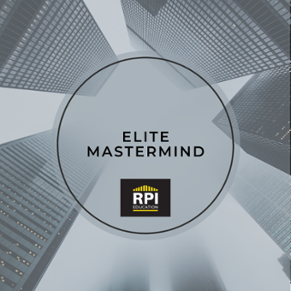

Elite Coaching
$20,000.00
Weekly coaching. for those looking to progress quickly with their wealth building.
Quantity
Add to Cart

Product Description
For people serious about wealth building and who want to wok wlh a coach, this is a focused program that helps you get results fast!
The RPI Elite Coaching Program includes
- A 60-minute 1 on 1 mastermind coaching session to create your Personalized Wealth Action Plan of what you are going to achieve in this program. You will leave this coaching session with 100% clarity on what your wealth goal is and what you will be focusing on throughout the duration of this program.
- You will receive a copy of your personalized wealth Blueprint (steps to follow and update every week) outlining your Action plan alongside specific action steps to take and experts to reach out to so they can help you get the answers you need to take action
- You will participate in Weekly Elite Coaching sessions every week for you to check in with your coach and discuss what you have completed over the past week, the outcome or obstacles and a set of new steps to continue to achieve over the following week.
- You also receive access to exclusive RPI curriculum including:
  - our Real Estate 101 Bundle (6 courses focused on key components of Real Estate Investing)
  - Our Joint Venture Workshop
  - Our Employee to Entrepreneur workshop!
- Members are also welcome to attend the Biweekly group coaching/deals sessions with experts where you can jump on these coaching sessions and have all of your questions answered by our team of experts as well as be presented with member only deals and opportunities
- And they receive FREE access to in person RPI Networking events as well as other in person workshops designed specifically for RPI Elite Coaching Members.
This group gets to the heart of what really matters and has members achieving their goals over and over again, keeping them coming back every year for more!
Because once you can finally see that you are able to create your BEST life, why would you settle for anything less?
We will be offering the ELITE Coaching group in 12 week, 6 month and 1 year programs
The investment for a 12 week program is $10,000
The investment for a 6 month program is $15,000
The investment for a 12 month program is $20,000
All of these coaching levels include 12 months access to the RPI Wealth Immersion Program ($1,997 value)
A 25% deposit is made to secure your spot and payment arrangements can be made if required
Each program is limited to 10 students.
What you get:
- 12 month's access to our Teachable Platform where you will have access to 7 modules consisting of recorded webinars, downloads and activities.
- 26 Group Coaching Sessions (every other Thursday)
- Access to our monthly events
- Access to our Members forum on our website and Facebook
- Real Estate Investing 101 Course
- Joint Venture Course
- Weekly progress/check in calls

https://bs413.infusionsoft.app/app/storeFront/showProductDetail?productId=105

All prices are displayed in CAD currency

All prices are displayed in CAD currency

